Exam Mate App

*Database Final Project*

# Credentials:

Done by:

* Omar Atef Kamel – Software Architect
* Shehab Ahmed Bassiouni – Software Architect
* Ali Osama Ramadan – PD & BI
* Mohamed Elsayed Raafat – Software Architect
* Ahmed Saeed Khalifa – PD & BI

To: **Eng. Rami** **Nagi**

# Introduction

## The App's Purpose and Objectives:

“**Exam Mate**” was developed to help educational organizations automate the whole process of “Creating Exams”, “Correcting Exams” and “Generating different types of reports”.

The APP was design specifically to make it faster and effortless preforming all the related tasks of giving multiple students their exams.

Thus, decreasing the costs and eliminating all delays regarding this matter.

Moreover, it shows the different skills we in the ITI track learned in using programing languages as SQL and C# Entity Framework Core.

Technical Overview

## Brief description:

This is a “Windows Form App” done by the 3-tier architecture in the C# Entity Framework (EF) Core. As well as, Mapped ERD on MS SQL-Server.

# Database Schema:

# ERD Model:

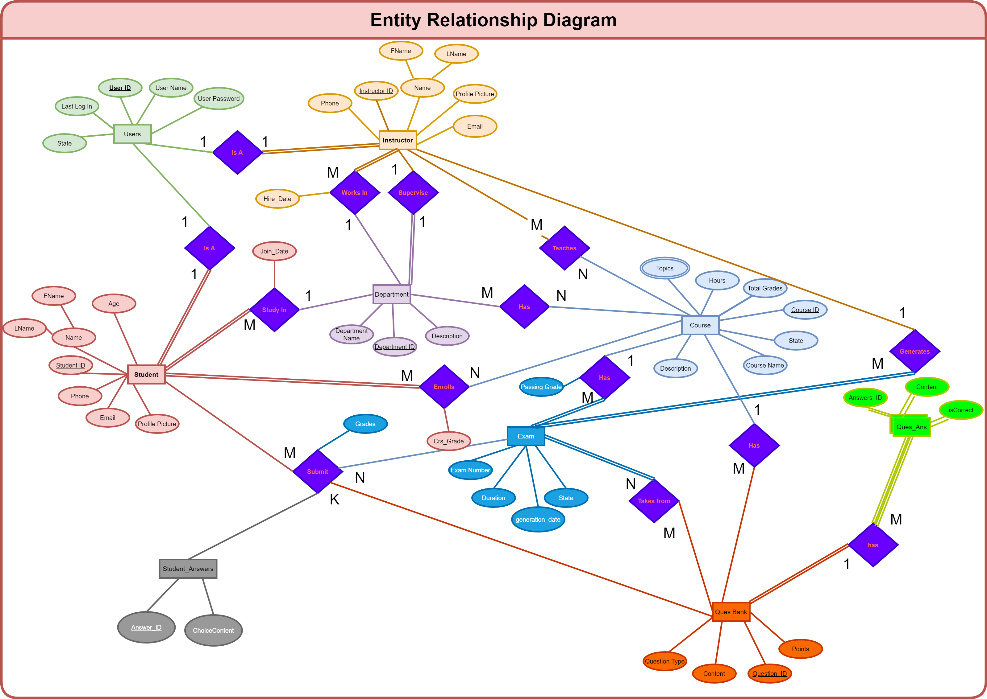

**Mapped ERD:**

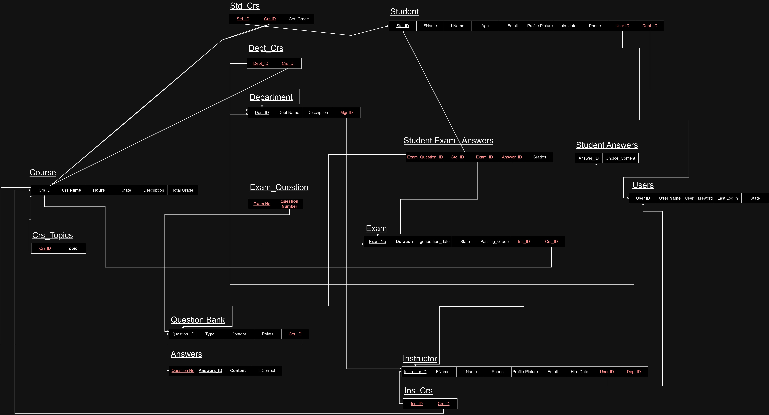

**Tables:**

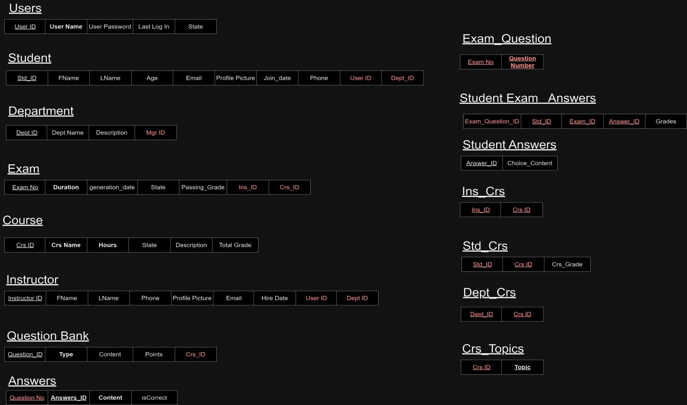

### **SQL-Server Enhanced ERD:**

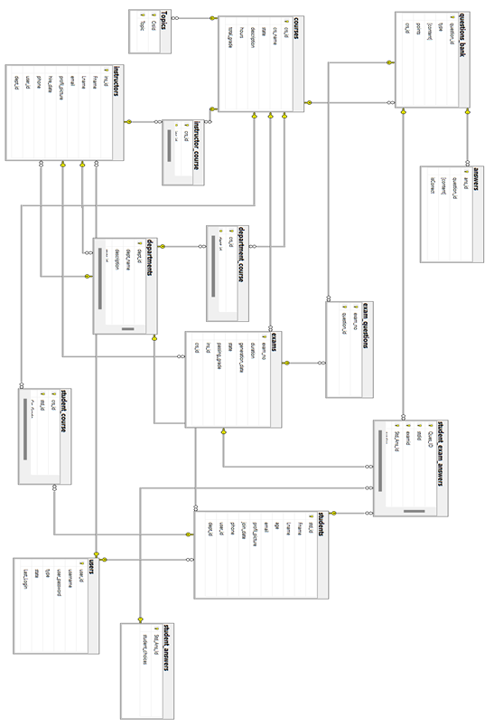

# Stored Procedures Documentation:

# Generate_Exam Procedure:

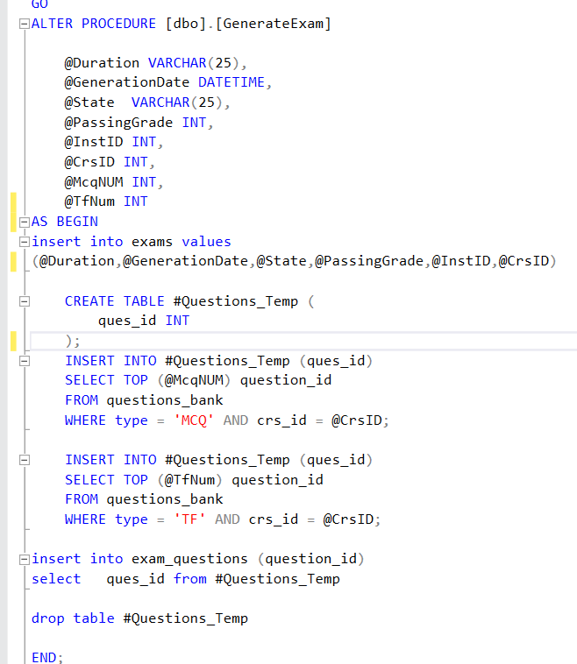

# Exam_Answers Procedure:

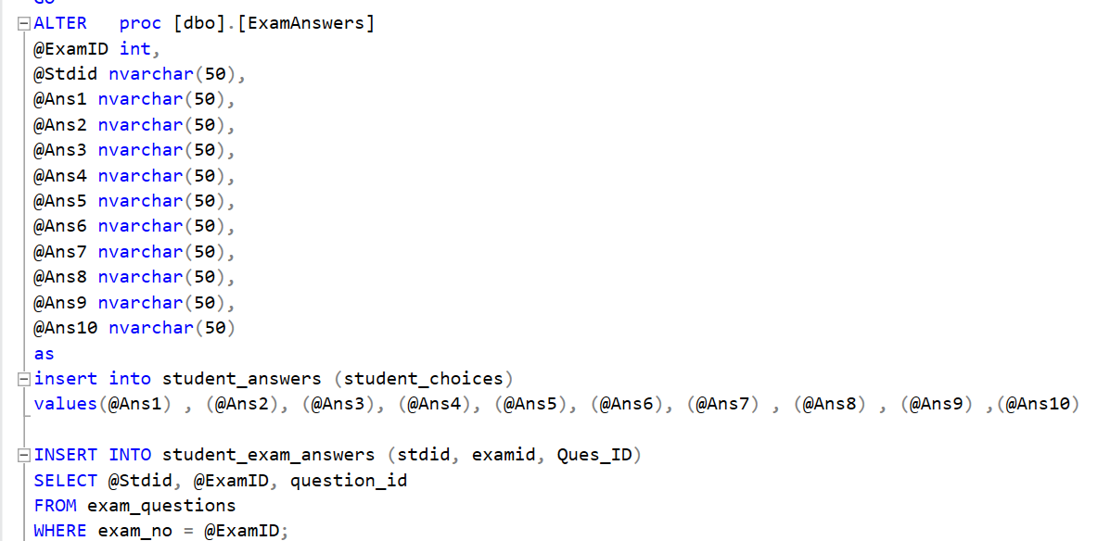

# Generate_Exam_Answers Procedure:

### 

# Example of SELECT * Procedure:

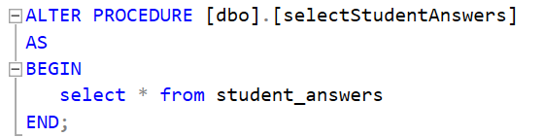

# Example of INSERT Procedure:

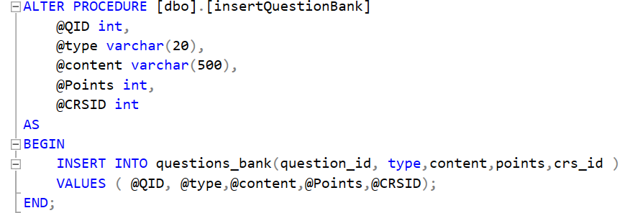

# Example of UPDATE Procedure:

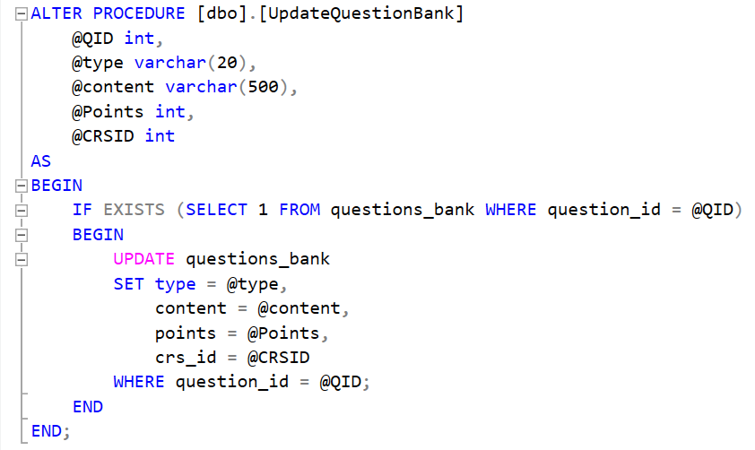

# Example of DELETE Procedure:

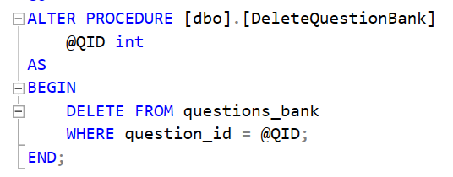

# Reports Documentation:

# Get Topic By Course ID Report:

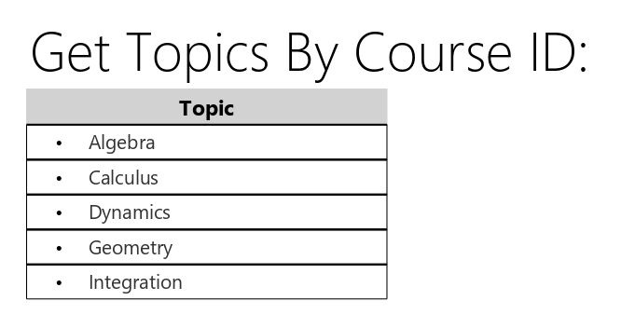

# Get Course Name and Student Number By Instructor ID Report:

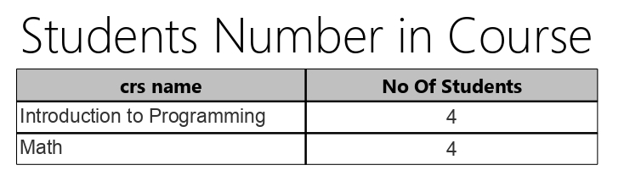

Get Students Grades By Student ID Report:

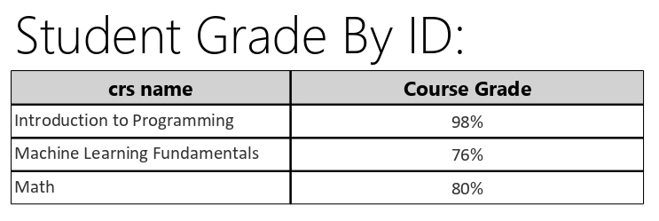

Get Students Information By Department ID Report:



# Get Questions And Students Answers By Exam Number Report:

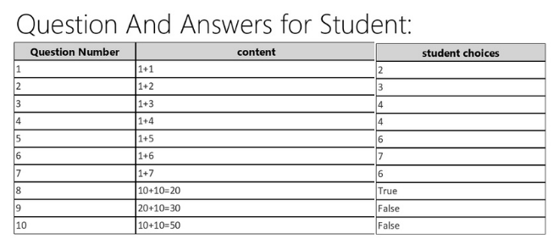

# Get Questions And Answers By Exam Number Report:

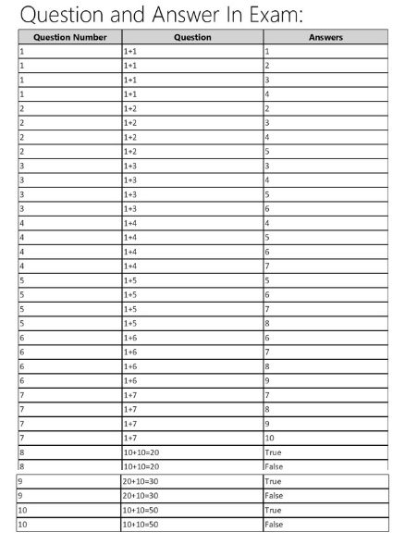

# User_Credential Report:

### **C# Back-end solution (using Visual Studio app):**

### **GUI Screen Shots:**

# Deployment Instructions:

* Visual Studio VS (or any related code editor)

Download the editor then install the packages:

* + ASP.NET Windows Form
  + Microsoft.EntityFrameworkCore.SqlServer
  + Microsoft.EntityFrameworkCore.Tools
  + Microsoft.VisualStudio.Web.CodeGeneration.Design

Then Download

* Microsoft Sql-Server Database from the official website

After that open “Exam Mate” on your VS and 🡪

* In the Package Manager: *Add-Migration Inicial2*
* Then in the same place: *Update-Database*

Now Run the application and enjoy

# User Manual:

1. First Login in using fast login instructions

2) in student form:

Student can solve exam or join course or

3) in instructor form

Instructor can add department , question , exam and courses

And manage them

